**SOFTWARE REQUIREMENT SPECIFICATION**

**Customer Module**

**Of**

**AZHRM system**

NEKFA AUSTRALIA (PVT) LTD

4th Floor, 131, W A D Ramanayake Mawatha, Colombo 02

Tel: 011 2375062| email: info@nekfa.com

www.nekfa.com

**Document Acceptance**

|  |  |
| --- | --- |
| Deliverable | Software Requirement Specification – User Module of AZ Human Resource Management |
| Deliverable Date |  |
| Client |  |

NEKFA Australia (PVT) LTD

|  |  |
| --- | --- |
| Name and Designation | Signature |
|  |  |
|  |  |

Document Amendment Register

|  |  |  |
| --- | --- | --- |
| Date | Author | Reviewer |
|  |  |  |
|  |  |  |

Contents

1

**1. Introduction** 4

1.1 Purpose 4

1.2 Scope 4

**2. Overall description** 4

2.1. User Characteristics 4

2.2. Operating Environment 4

**3. SYSTEM FEATURES** 5

**1. Login** 5

1.1 Flow chart 5

1.2 Description 5

1.3 Alternate Flow 6

1.3.1 Forgot Password 6

1.4 Functional Requirements 7

**2. Sign Up** 7

1.1 Flow chart 7

1.2 Description 7

1.3 Functional Requirements 8

**4. Dashboard** 8

4.1 Description 8

After successful login, users are redirected to their dashboard or main page. The side menu is accessible from here. 8

**5. My account details overview & Modify** 9

5.1 Flow chart 9

5.2 Description 9

1.3 functional Requirements 10

**6. Password Change** 10

6.1 Description 10

6.2 functional Requirements 11

**7. Logout** 11

6.1 Description 11

6.2 Functional Requirement 11

**8. My All products** 11

8.1 Description 11

8.2 Functional Requirement 12

**9. Add new AZHRM Package** 12

9.1 Description 12

9.2 Functional Requirement 12

**10. Product Details** 13

10.1 Description 13

10.2 Functional Requirement 13

**11. Upgrade Product** 13

11.1 Description 13

11.2 Functional Requirement 14

**12. Upgrade Product** 14

12.1 Description 14

12.2 Functional Requirement 14

**13. Request to cancel** 14

13.1 Description 14

13.2 Functional Requirement 15

**14. Manage payment method** 15

14.1 Description 15

14.2 Functional Requirement 15

Appendix - 16

**Wireframes** 17

# **1. Introduction**

## 1.1 Purpose

The purpose of the HR System website is to streamline and automate various human resources processes, including employee management, attendance tracking, leave management, and performance evaluation.

## 1.2 Scope

The system will cover the entire employee lifecycle, from onboarding to off boarding, and provide administrators with tools to efficiently manage HR tasks.

# **2. Overall description**

## 2.1. User Characteristics

* Administrators: HR administrators will have access to features such as employee management, leave approval, and performance evaluation.
* Employees: Users will include employees who interact with the system for tasks such as submitting leave requests, accessing performance feedback, and updating personal information.

## 2.2. Operating Environment

The entire set of applications is built on technologies to ensure product performance and durability. The following technologies and software are used to develop the application.

       ∙ OS –Windows

       ∙ Database – MSSQL

       ∙ Platform Language – ASP.Net MVC

# **3. SYSTEM FEATURES**

# **1. Login**

## 1.1 Flow chart

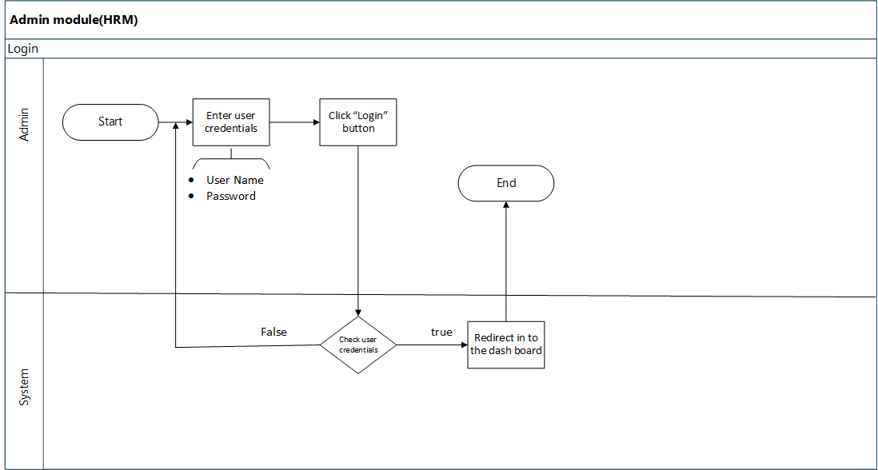

## 1.2 Description

**Use case** User Log in

**Purpose**  System allows user to login in to the system.

**Actors**  User

**Pre-condition** User should have an internet connection.

User should have a web browser.

User should be permission allowed user.

**Basic Flow**

* The System navigates the user to login interface.
* The system should facilitates to user to enter the user name and password as follows.

|  |  |  |  |
| --- | --- | --- | --- |
| Field | Field Type | Propriety | Remark |
| Email | Text Field | Mandatory |  |
| Password | Text Field | Mandatory | * Should be include minimum 6 characters (Including at least one numeric 0-9, A-Z, Special characters). * System should not allow to enter simple password. Show hint message in password field. |

The system should validate the entered email and password, check whether that the entered email is a valid email in the system, and that the required password is entered for the entered username.

User should Click “I’ m not robot” and then User clicks the “Login “button and if user successfully entered user credentials system direct in to the dashboard as a logged in user.

## 1.3 Alternate Flow

### 1.3.1 Forgot Password

* User may use the “Forgot password” option when the user attempts to log in to the system, But the login process is fail or if forgot the password.
* User click the *“Forgot password”* link in the login interface.
* Then system displays the text field to enter the user name and display description as *"Enter your username and you will receive an email containing a verification link to reset your password”.*
* *User clicks the “Reset password” Button.*
* System sends verification link to the user’s email with token.
* Reset password URL should be encrypt by the system (format: Page URL + User ID + User Name + Date + Time).
* User clicks the link.
* Then user redirect into the password reset page.
* User enter new password and re- type the new password.
* System validates the both password.
* Then clicks the “Confirm” button.
* System display the *“password changed successful”.*
* Then user redirect in to the login interface.
* If user want to cancel the reset process user click the “Cancel” button.
* Then system should redirect user in to the login interface.

**Error Flow**

* If user entered invalid Password or User name System display error message *as "invalid username or password".*
* If user try to login without filling the user credentials system displays error message as *"Please enter your username and password ".*

## 1.4 Functional Requirements

* **REQ-1:** User should be able to login in to the system.
* **REQ-2:** User should be able to change the password.
* **REQ-3**: User should be able to reset the password.

# **2. Sign Up**

## 1.1 Flow chart

## 1.2 Description

**Use case** User sign up

**Purpose**  System allows user to sign up in to the system.

**Actors**  User

**Pre-condition** User should have an internet connection.

User should have a web browser.

User should be permission allowed user.

**Basic Flow**

* The System navigates the user to signup interface.
* The system should facilitates to user to enter the following details.

|  |  |  |  |
| --- | --- | --- | --- |
| Field | Field Type | Propriety | Remark |
| Full Name | Text field | Mandatory | * Should be an alphabetic value. |
| Email | Text field | Mandatory | * Should be an alphabetic value. |
| Phone | Text field | Mandatory | * Should be numeric value. |
| Company Address | Text field | Mandatory | * Should be an alphabetic value & numeric value |
| Country | Text field | Mandatory | * Should be an alphabetic value. |
| Currency | Text field | Mandatory | * Should be an alphabetic value. |
| Password | Text Field | Mandatory | * Should be include minimum 6 characters (Including at least one numeric 0-9, A-Z, Special characters). |
| Confirm Password | Text Field | Mandatory | * Should be include minimum 6 characters (Including at least one numeric 0-9, A-Z, Special characters). |

* The system should validate the entered user full name, email, phone, company address, country, currency password & confirm password, check whether that valid details in the system, and that the required password is entered for the entered username.
* User clicks the “sign up “button and if user successfully entered user credentials system then user can log into system.

**Error Flow**

* If user entered invalid details System display error message.
* If user try to sign up without filling the user credentials system displays error message.

## 1.3 Functional Requirements

* **REQ-1:** User should be able to sign up in to the system.

# **4. Dashboard**

## 4.1 Description

**Use case** User dashboard

**Purpose**  System allows user to dashboard in to the system.

**Actors**  User

**Pre-condition** User should have an internet connection.

User should have a web browser.

User should be register (sign up) that system.

User should be login.

**Basic flow**

After successful login, users are redirected to their dashboard or main page. The side menu is accessible from here.

# **5. My Profile overview & Edit**

## 5.1 Flow chart

## 5.2 Description

**Use case** User My account details overview & Modify

**Purpose**  System allows user to view account details.

**Actors**  User

**Pre-condition** User should have an internet connection.

User should have a web browser.

User should be permission allowed user.

**Basic Flow**

* After click my profile user can show account details overview. System display following details,
* Name
* Email
* Phone No
* Address
* Country
* Currency
* These details are disable. If user need to edit their details user should click edit button.
* If User need to change password user should click change password.
* In this page user cannot edit their email address. It display as a label.

User should be able to do the following functionality,

* Edit
* Change password.

**Edit Option**

* If user click edit button user can edit their account details.
* Customer cannot edit their email address.
* After enter edit their details user can update their details. User should click update button.

**Change password Option**

* If user click change password button user can change password.
* Customer cannot edit their email address.
* After enter new password & confirm password then User should click confirm button.
* Password should be in the following,
* Should be include minimum 6 characters (Including at least one numeric 0-9, A-Z, Special characters).

## 1.3 functional Requirements

* User should be able to view account details.
* User should be able to edit account details.
* User should be able to change password.

# **6. Password Change**

## 6.1 Description

**Use case** Password change

**Purpose**  System allows user to password change

**Actors**  User

**Pre-condition** User should have an internet connection.

User should have a web browser.

User should be permission allowed user.

**Basic flow**

* If user want to change the password, user can use the “*Change password* “option.
* If user click change password system display popup message.
* Upon click the change password, user has to enter the current password, new password and retype the new password.
* When enter the password there is an option for show the password.
* System should authenticate the current password and validate the both password.
* Password should be in the following, Should be include minimum 6 characters (Including at least one numeric 0-9, A-Z, Special characters).
* Then clicks the “*Submit*” button.
* System display the *“password changed successful”.*
* Then user redirect in to the login interface.

## 6.2 functional Requirements

* User should be able to change password.

# **7. Logout**

### 6.1 Description

**Use case** Log out

**Purpose**  System allows user to logging out from the system.

**Actors**  Authorized user

**Pre-condition** User should have an internet connection.

User should have a web browser.

User should logged in to the system.

User should be permission allowed user.

**Basic Flow**

* User clicks the “Log out” button.
* Once click logout button system should destroy the created session and redirect to the login interface.
* When session is destroy system should redirect to the Login interface.

### 6.2 Functional Requirement

* **REQ-1:** User should be able to logout from the system.

# **8. My Products**

### 8.1 Description

**Use case** View all products

**Purpose**  System allows user to view products

**Actors**  Authorized user

**Pre-condition** User should have an internet connection.

User should have a web browser.

User should logged in to the system.

User should be permission allowed user.

**Basic Flow**

* User clicks the “Product” sub menu.
* Once click Product sub menu system should redirect to the product page.
* User can view my products.
* If user add products earlier user can show following details about their add product.
* In this section user can show many entries & user can select quantity of entries.
* System display following details.

|  |  |  |  |
| --- | --- | --- | --- |
| Field | Field Type | Propriety | Remark |
| Company Name | Grid view | Mandatory |  |
| Package | Grid view | Mandatory |  |
| Employee Count | Grid view | Mandatory |  |
| Status | Grid view | Mandatory |  |
| Due Amount | Grid view | Mandatory |  |
| Next billing date | Grid view | Mandatory |  |
| Action | Grid view | Mandatory |  |

* User should be able to do the following functionality,
* Add product

### 8.2 Functional Requirement

* **REQ-1:** User should be able to view my product details.

# **9. Add New AZHRM Package**

### 9.1 Description

**Use case** add new package

**Purpose**  System allows user to add products

**Actors**  Authorized user

**Pre-condition** User should have an internet connection.

User should have a web browser.

User should logged in to the system.

User should be permission allowed user.

**Basic Flow**

* User clicks the “add product” button.
* Once click add product button system should redirect in to the add product page.
* User can view details about package and user can choose plan.
* If user click choose plan user can buy it.
* User can show these details as a grid view.
* Types of package,
* Basic
* Premium
* Premium plus
* Enterprise

### 9.2 Functional Requirement

* **REQ-1:** User should be able to choose package.

# **10. Product Details**

### 10.1 Description

**Use case** view product details

**Purpose**  System allows user to view product details

**Actors**  Authorized user

**Pre-condition** User should have an internet connection.

User should have a web browser.

User should logged in to the system.

User should be permission allowed user.

**Basic Flow**

* User clicks the “action icon” or “choose plan”.
* Once click action redirect in to add product page
* User can view there entered details.
* System display following details
* Company name
* Country
* Package
* No of employee
* User should be able to do the following functionality.
* Edit
* Upgrade
* Request to cancel

### 10.2 Functional Requirement

* **REQ-1:** User should be able to view product details.
* **REQ-2:** User should be able to upgrade package.
* **REQ-3:** User should be able to request cancel.

# **11. Upgrade Product**

### 11.1 Description

**Use case** Upgrade product.

**Purpose**  System allows user to upgrade product.

**Actors**  Authorized user

**Pre-condition** User should have an internet connection.

User should have a web browser.

User should logged in to the system.

User should be permission allowed user.

**Basic Flow**

* User clicks the “upgrade” button.
* Once click upgrade button system display pop up message.
* Then User can view packages.
* In this page user can select upgrade their package.
* Current package was highlighted.
* If user need to edit details, user should click edit button, enter edit details & click upgrade button.
* If user need to cancel request, user should click cancel request button.

### 11.2 Functional Requirement

* **REQ-1:** User should be able to cancel request.
* **REQ-2:** User should be able to upgrade packages.

# **12. Request to cancel**

### 12.1 Description

**Use case** cancel request

**Purpose**  System allows user to cancel request.

**Actors**  Authorized user

**Pre-condition** User should have an internet connection.

User should have a web browser.

User should logged in to the system.

User should be permission allowed user.

**Basic Flow**

* User clicks the “request cancel” button.
* If user click request cancel button system display popup message.
* And display “Are you sure?” confirmation message.
* Then user need to click “yes”.
* After click yes user can cancel request, sent the notification email to the admin.
* After canceled, in product list updated status as “canceled request”.

### 12.2 Functional Requirement

* **REQ-1:** User should be able to cancel request.

# Appendix -

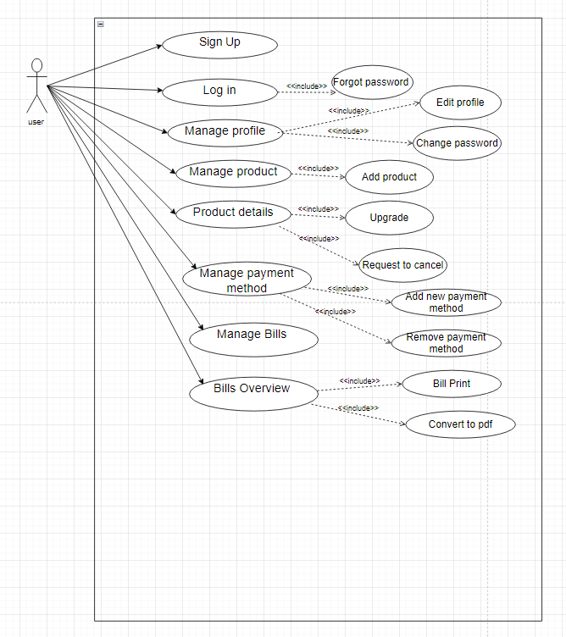1. Use case diagram

# **Wireframes**

1. Registration Form

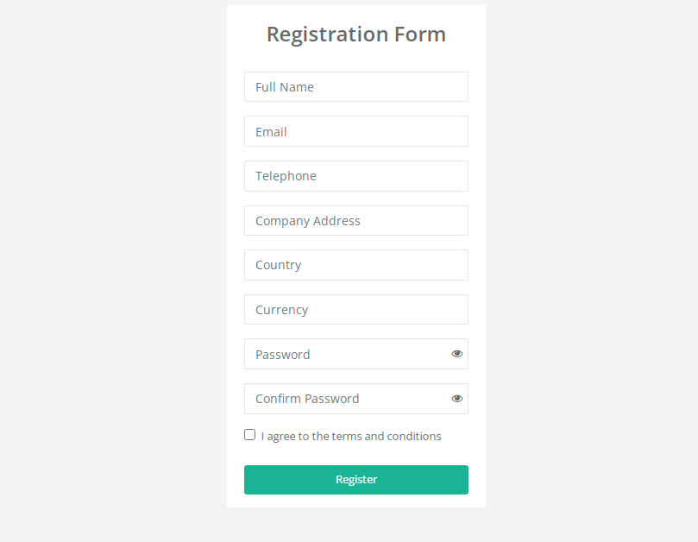

2. Login

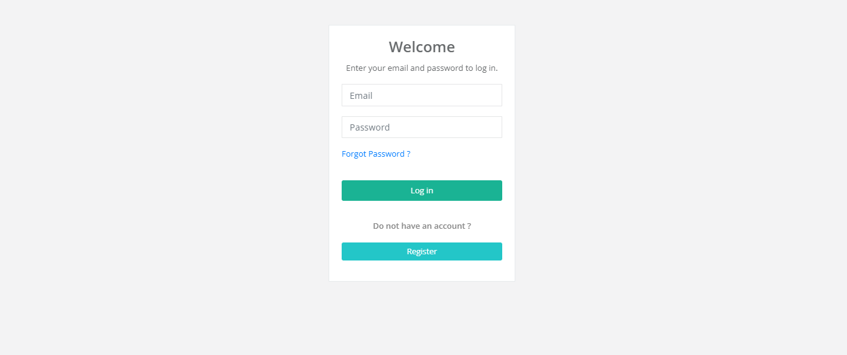

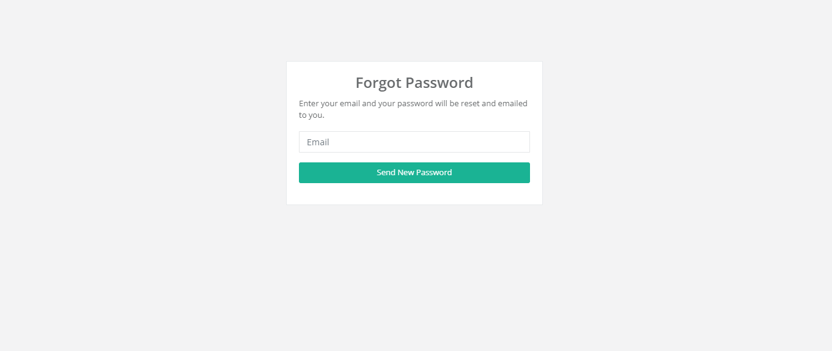3. Forgot Password

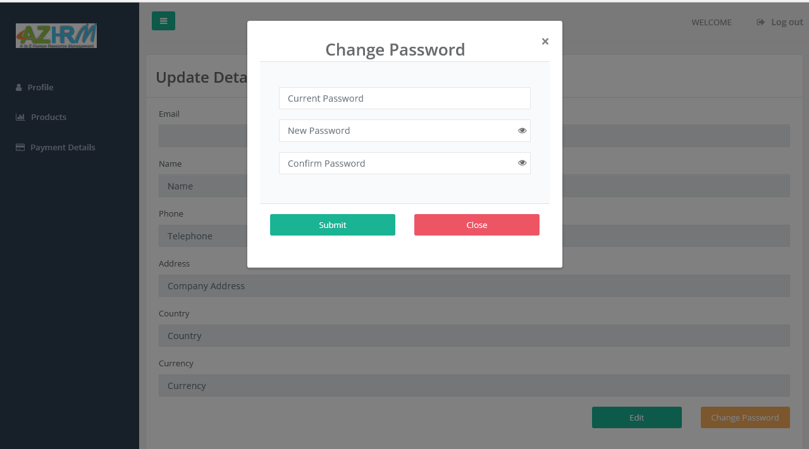4. Change Password

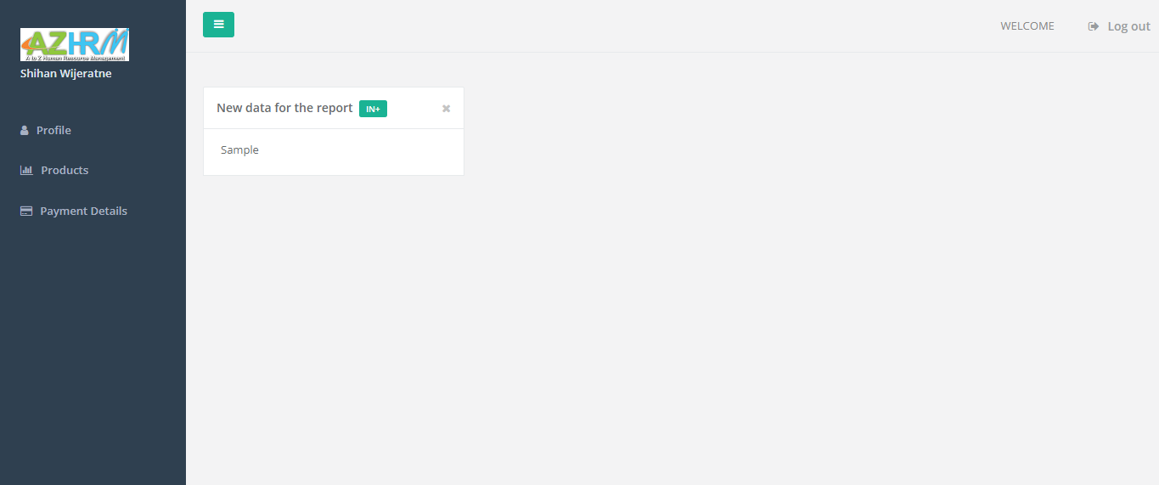 5. Dashboard

6. Profile

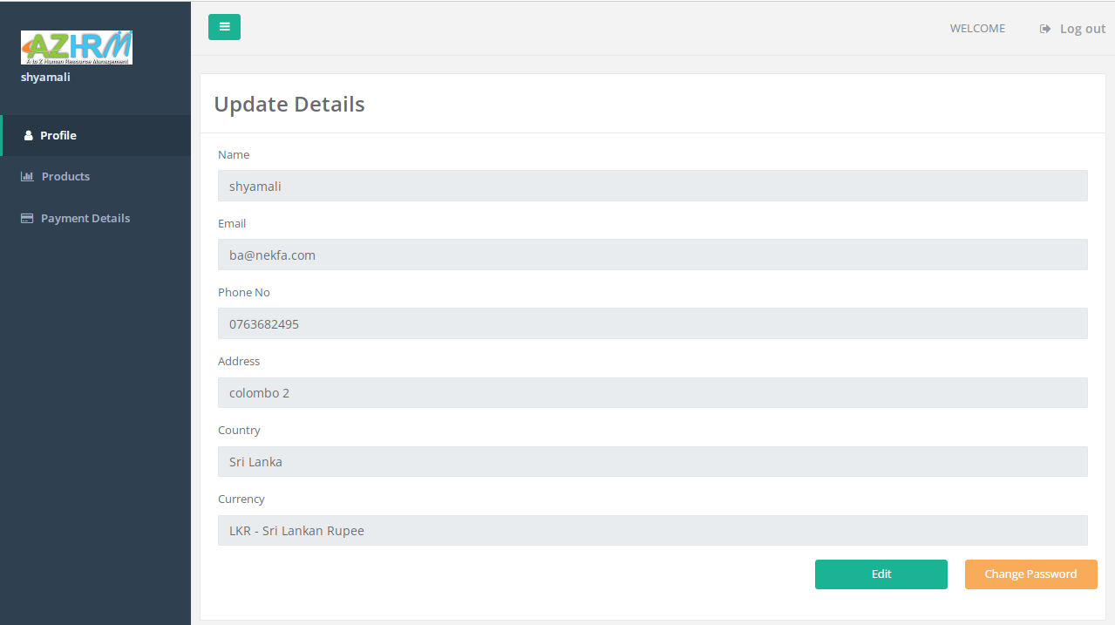Update Details

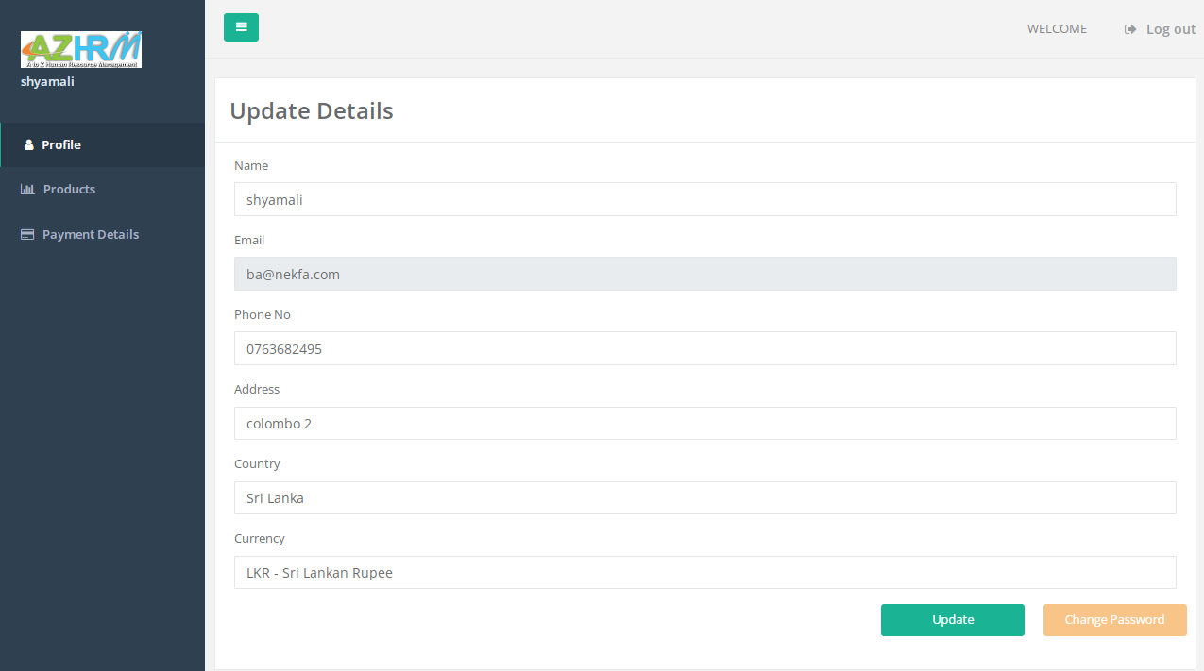7. After Click edit button

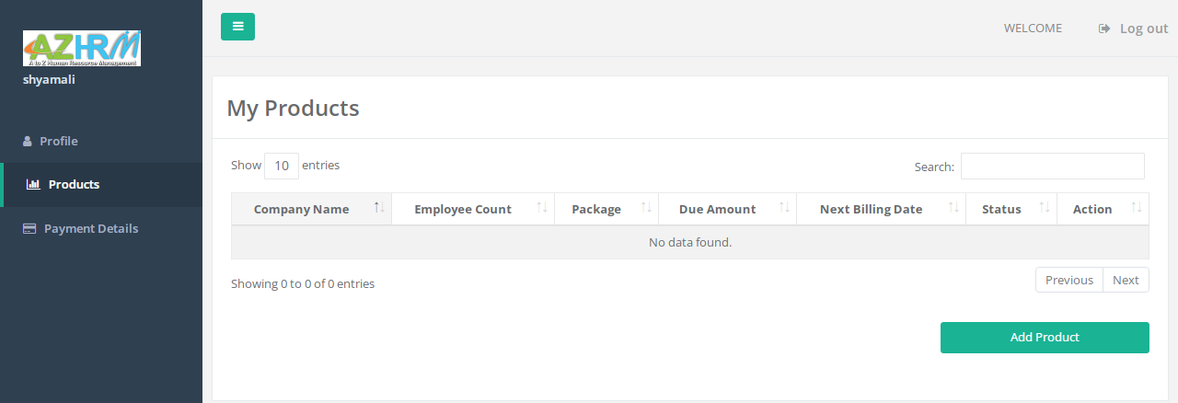8. My Products

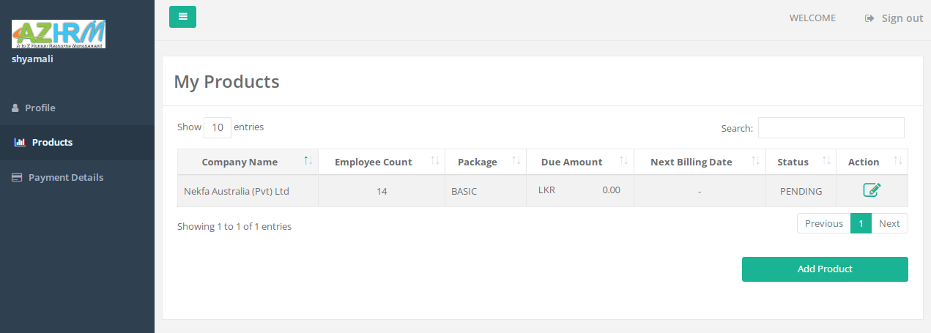9. After add my products

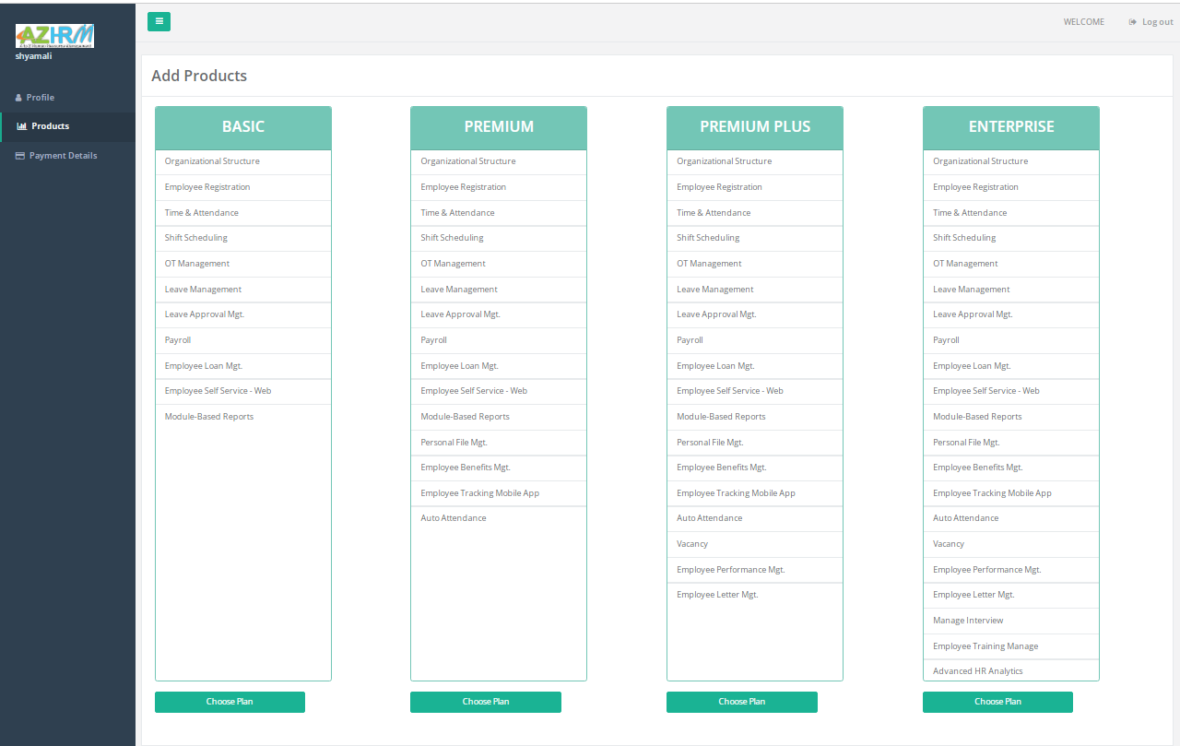10. Add Products

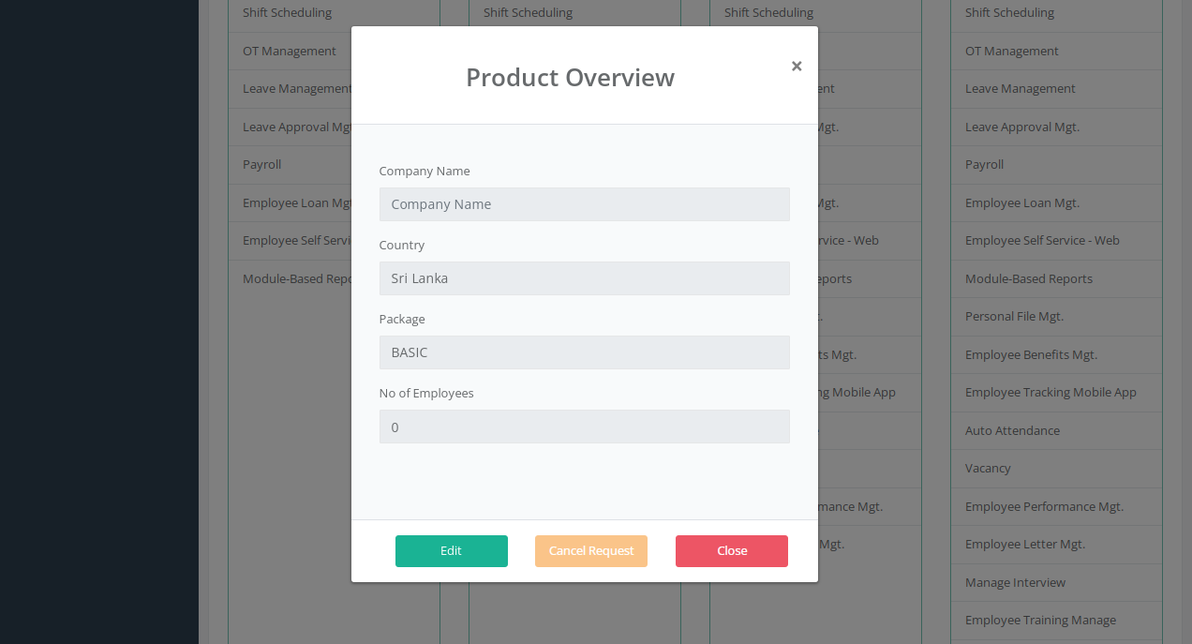11. Product Overview

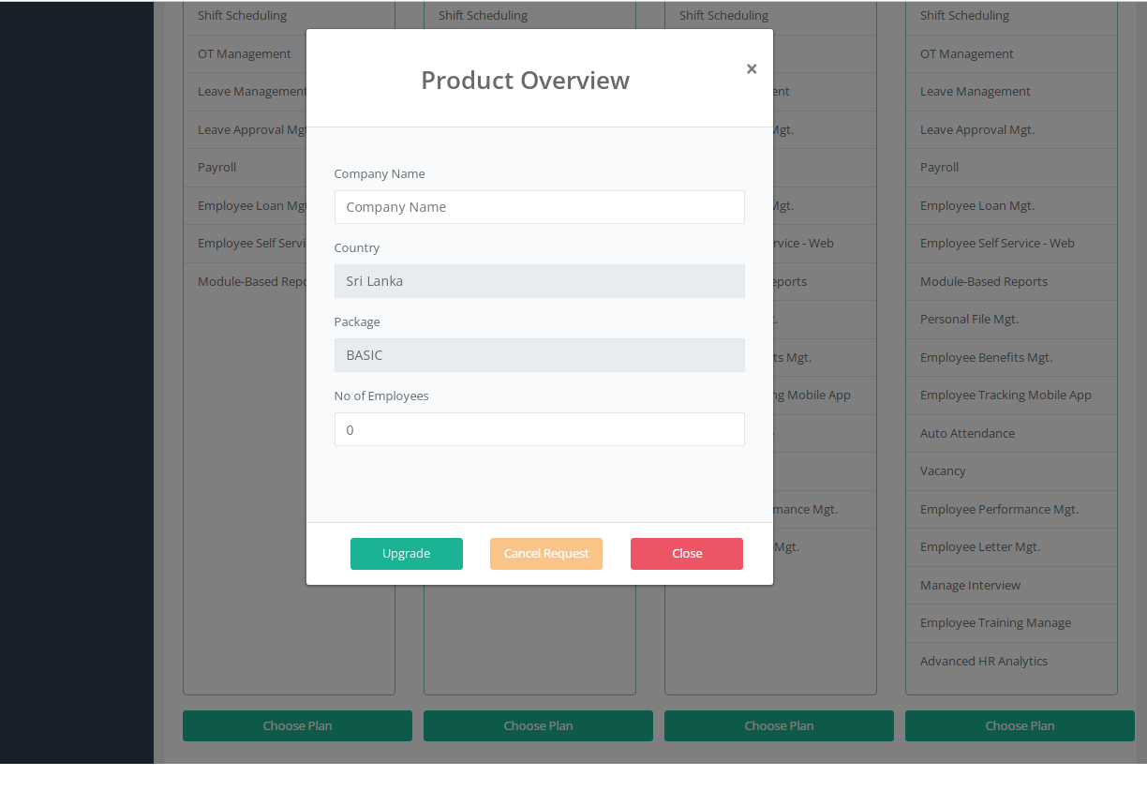12. after Click Edit – Product Overview

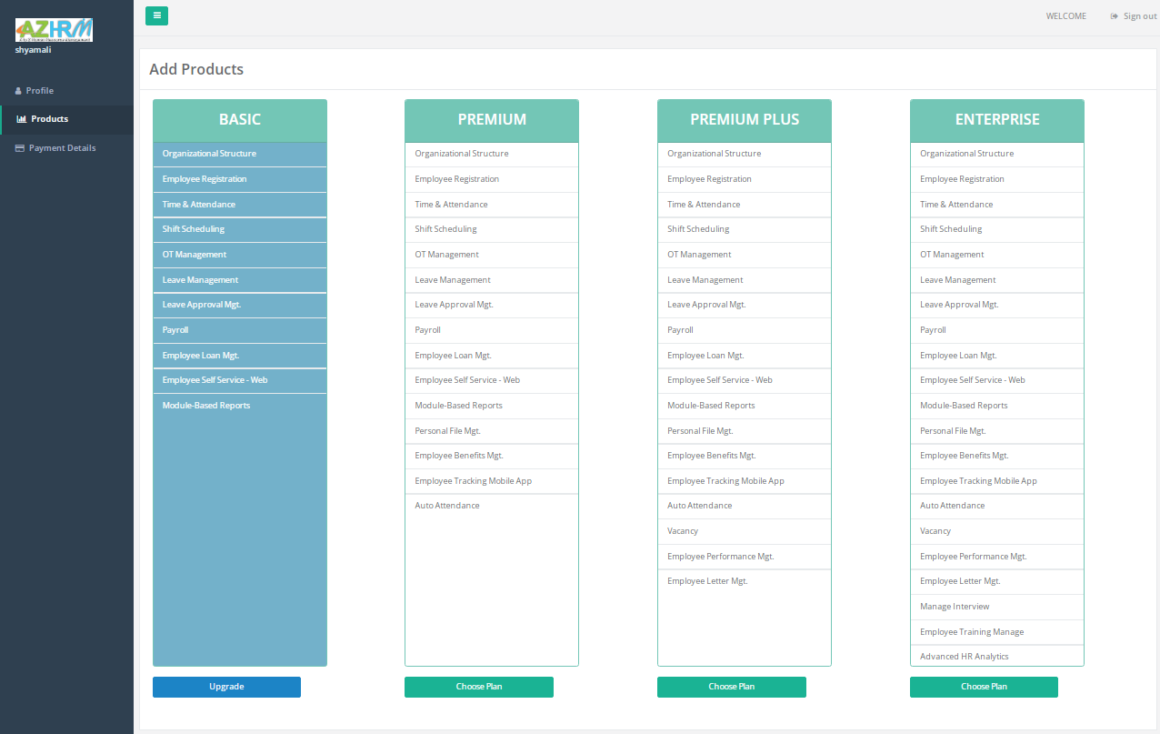13. Click action icon –Edit details

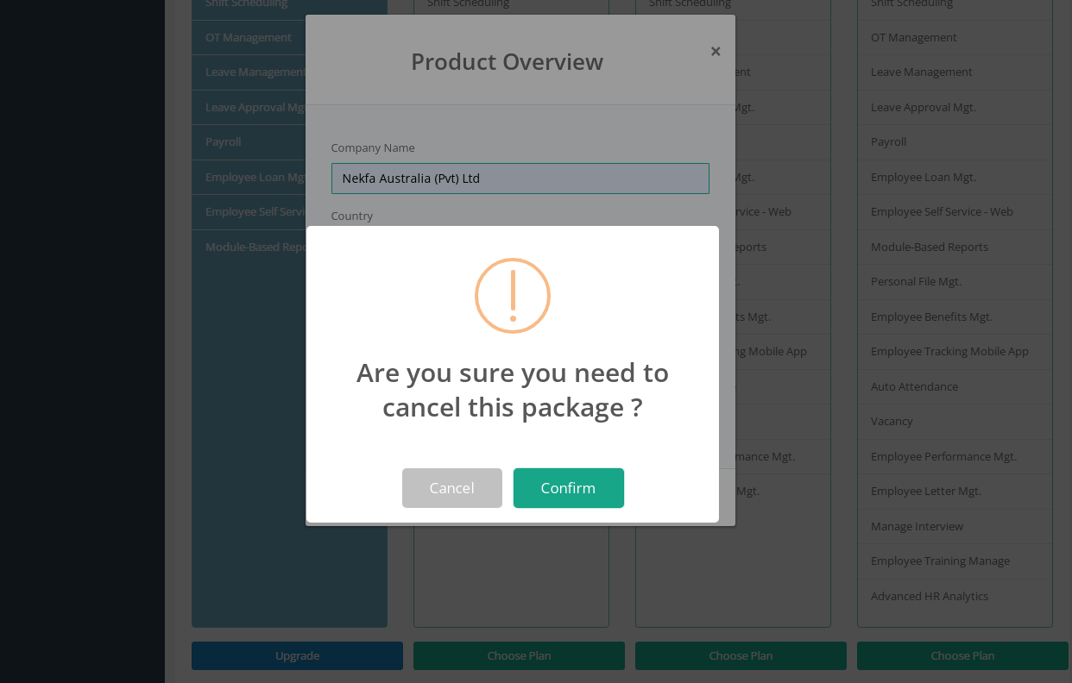14. Cancel Request

